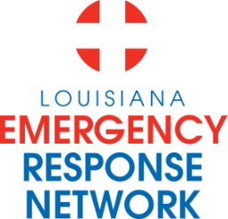

Louisiana Emergency Response Network
Board Meeting
January 26, 2012
2:00pm – 4:00pm
Location: Louisiana Municipal Association (LMA)
700 North 10th Street Baton Rouge, LA 70821

AGENDA
1. Welcome and Introduction of New LERN Board Members
2. Roll Call and establish a quorum
3. Approval of Agenda
4. Approval of Minutes of August 19-20, 2011 Board Meeting
5. New Business:
a. Ratification of Executive Director C. Barrett
b. Election of Officers C. Barrett
c. Ratification of Commission Members P. Hargrove
d. Communication Center (North) Report J. Daily
e. Contract Renewal - Legal Services C. Barr
f. FY 2012-2013 Proposed Budget C. Barr
g. Proposed Future Trauma Center Network R. Coscia
h. Patient Choice C. Cangelosi
i. Approval of Hospital Agreements P. Hargrove
j. EMS Participation/BAA for EMS Registry P. Hargrove
k. Strategic Priorities/SSA Board Retreat 2011 C. Slaughter
6. Administrative Report:
a. Budget Update FY 2011-12 Treasurer/C. Barr
b. Medical Director R. Coscia
c. Executive Director’s Report P. Hargrove
d. Chairman’s Report C. Barrett
& Installation of Officers
7. Public Comment
8. Adjournment

NEXT MEETING DATE April 19, 2012 2:00 PM – 4:00 PM at LERN Central Office

